**Tomcat installation**

1.Create a Virtual machine of OS ubuntu or Centos

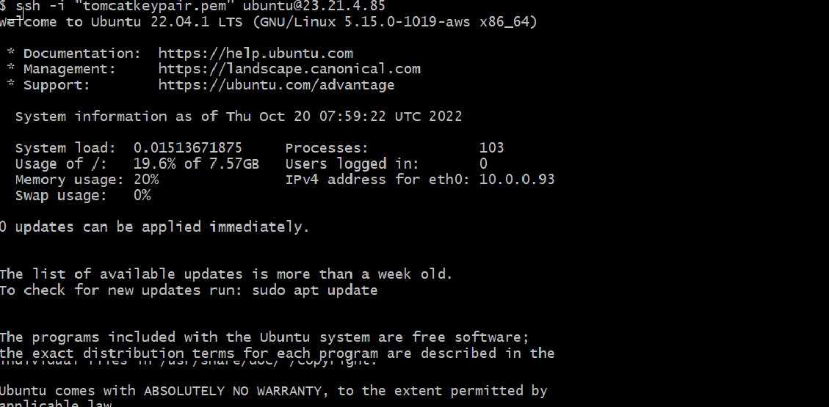

2.Install tomcat in the /opt directory

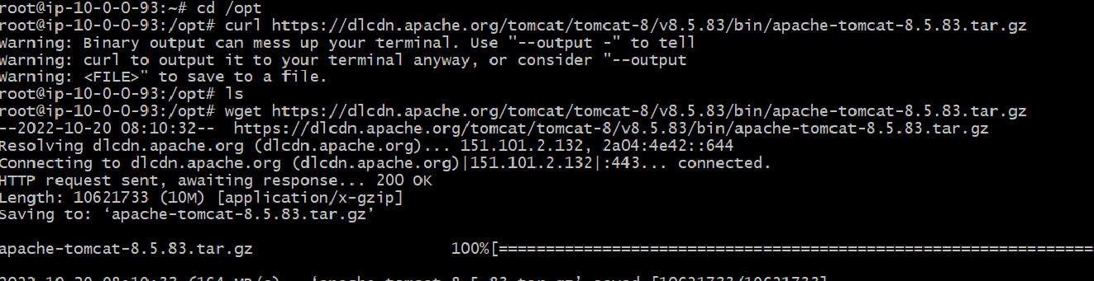

3.Start the tomcat server and check on the browser if

tomcat is up and running

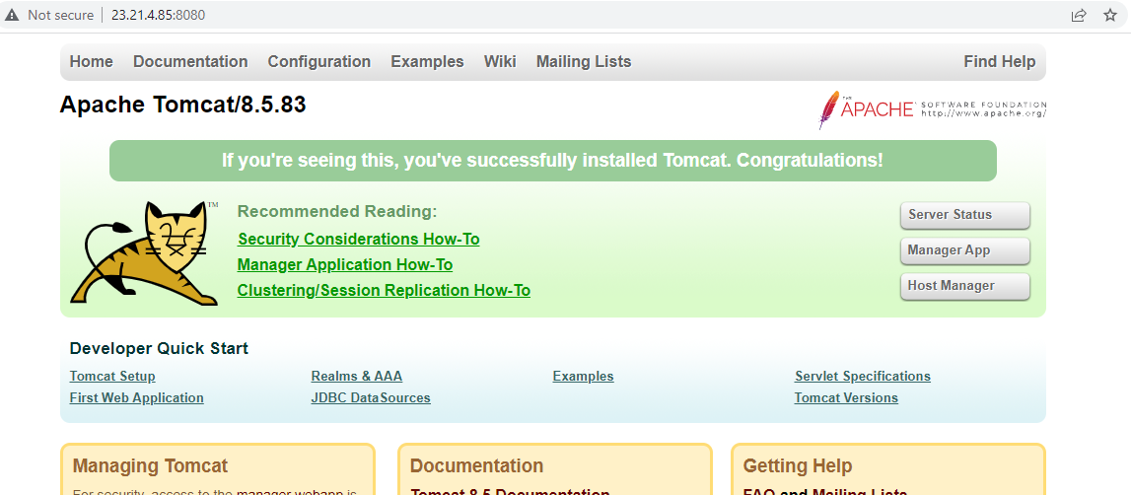

4.Set up the manager app

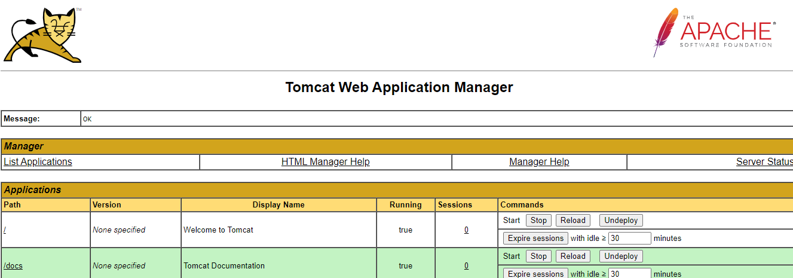

5.Set tomcat-users and roles

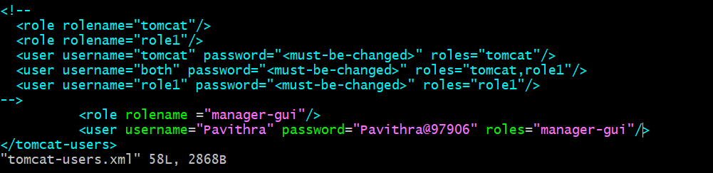

6.Stop and restart tomcat

